Deployment Guide

Health Check Data Domain

Version 1.0

August 08, 2022



## Document Information

|  |
| --- |
| Use Case / Content Request (UCMS) # 44269 & 53361 |
| CB Prepared by  Kumar, Dinesh <[dkumar376@dxc.com](mailto:dkumar376@dxc.com) >, Rawal, Rahul <rrawal5@dxc.com> |
| Developer  CHINTALAPUDI, ANAND VARDHAN <a.chintalapudi@dxc.com> |
| Design  Sethupathy, Balaji Hamsaraj <balaji.sh@dxc.com> |
| Approved by  Sethupathy, Balaji Hamsaraj <balaji.sh@dxc.com> |
| Owning Capability  Backup |
|  |

## version history

|  |  |  |  |
| --- | --- | --- | --- |
| **Version** | **Version date** | **Updated by** | **Affected section and description of change** |
| 1.0 | 2022-08-08 | CHINTALAPUDI, ANAND VARDHAN <a.chintalapudi@dxc.com> | Initial Release |
|  |  |  |  |
|  |  |  |  |
|  |  |  |  |
|  |  |  |  |
|  |  |  |  |
|  |  |  |  |
|  |  |  |  |
|  |  |  |  |
|  |  |  |  |

table of Contents

Document Information 1

version history 2

1 OVERVIEW 4

1.1 HIGH LEVEL OVERVIEW 4

1.2 Platforms and products covered 6

1.3 PREREQUISITES 6

2 Design 7

2.1 Design 7

3 Deployment Procedure 8

3.1 Backup Server 8

3.2 Dashboard 10

# OVERVIEW

## HIGH LEVEL OVERVIEW

This Automation idea is to generate Health Check dashboard for Data Domain. Here we have two Scripts, one will be run on the windows Backup Server / Jump Server which will send mails based on schedule and another is Dashboard Script, which need to run on Local machine to generate the dashboard.

The Health Check Script can be run for Windows and Unix Machines from the windows JUMP Server or Backup Server. This will perform 07 Health Checks which are as follows,

**1. OS Version:** OS version is shown and represented as below mentioned color in Dashboard and represented as **“D”**  if it’s **Disabled.**

|  |  |  |
| --- | --- | --- |
| **R** | **G** | **Value** |
| If No output available | If Output available | Success / Failure |

**2. Serial Number:** Serial Number is shown and represented as below mentioned color in Dashboard and represented as **“D”**  if it’s **Disabled.**

|  |  |  |
| --- | --- | --- |
| **R** | **G** | **Value** |
| If No output available | If Output available | Success / Failure |

**3. Capacity Status:** It gives Percentage of Used Capacity to Total Capacity and represented as below mentioned color in Dashboard and represented as **“D”**  if it’s **Disabled.**

|  |  |  |  |
| --- | --- | --- | --- |
| **R** | **Y** | **G** | **Value** |
| Use%>90% | Use%>85% and <90% | Use%<85% | Use Capacity / Total Capacity |

**4. Cleaning Status:** Cleaning status is shown and represented as below mentioned color in Dashboard and represented as **“D”**  if it’s **Disabled.**

|  |  |  |
| --- | --- | --- |
| **R** | **G** | **Value** |
| Status other than Cleaning failed | Cleaning finished/cleaning running | Success / Failure |

**5.Cleaning Schedule:** It gives the Cleaning Scheduleand represented as below mentioned color in Dashboard and represented as **“D”**  if it’s **Disabled.**

|  |  |  |
| --- | --- | --- |
| **R** | **G** | **Value** |
| If No output available | If Output available | Success / Failure |

**6. Disk Failure Status:** It gives Percentage of Failed Disks to Total Disks and represented as below mentioned color in Dashboard and represented as **“D”**  if it’s **Disabled.**

|  |  |  |
| --- | --- | --- |
| **R** | **G** | **Value** |
| >=1 | 0 | Failed Disks / Total Disks |

**7. Active Alerts:** It gives count of Active Data Domain Alerts and represented as below mentioned color in Dashboard and represented as **“D”**  if it’s **Disabled.**

|  |  |  |
| --- | --- | --- |
| **R** | **G** | **Value** |
| >=1 | 0 | Count of Alerts |

## Platforms and products covered

Windows Platforms

 Windows 2003 |  Windows 2008 |  Windows 2012 |  Windows 2016

UNIX Platforms

AIX |  HP-UX |  Linux Red Hat |  Linux SUSE |  SunOS (Solaris)

Backup Products

 Avamar (AV) |  Legato |  NetBackup |  Tivoli Storage Manager

## PREREQUISITES

* Script Hosting System should have powershell version 3.1 and above.
* WINRM service should be enabled on the Hosting & Windows backup servers.
* Automation user should have necessary permission to access all the BKP Application directories without sudo access.

# Design

## Design

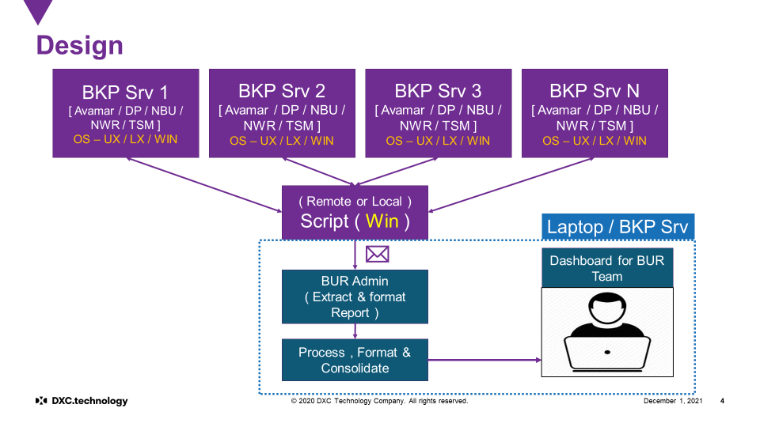

# Deployment Procedure

## Backup Server

Logon to the Windows Backup Server or the Jump Server and copy the solution to any directory and create folder as **BURAuto\HC\DataDomain.**

Please find the zip file in share point as **“HC-DD.zip”.**

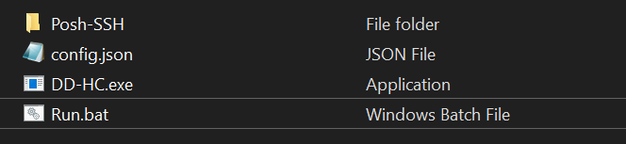

* Before Extracting go to the properties of Zip file and unblock the file if it is blocked.
* This will ask the user credentials to logon to Windows Backup server or Linux Backup server for remote connections and it does not require any credentials for running locally on windows Backup Server.
* This will create **cred.xml** file with given credentials which is encrypted.
* Schedule the **run.bat** file accordingly.
* If you have more than one backup server , create separate directory with the servername and perform the steps mentioned above.

**Config.json Parameters:**

**Info 1:** Change the parameters under this category accordingly.

* **Account :** Provide the Account name.
* **BackupServer:** Provide the BackupServer name Unix Machine
* **ReportPath:** Provide the path of **BURAuto\HC** folder separated by **“\\”.**

Eg: C:\\ BURAuto\\HC

* **OsType:** Provide as **Windows** or **NonWindows**
* **deleteFilesOlderThanInDays :** Provide number of old days files need to be deleted in the given report path.

**Enabling and Disabling Health Checks:**

**Enabled :** Enables the Health Check

**Disabled:** Disables the Health Check

* **OSVersion:** Enabled or Disabled Accordingly.
* **SerialNumber:** Enabled or Disabled Accordingly.
* **CapacityStatus:** Enabled or Disabled Accordingly.
* **CleaningStatus :** Enabled or Disabled Accordingly
* **CleaningSchedule:** Enabled or Disabled Accordingly.
* **DiskStatus:** Enabled or Disabled Accordingly.
* **AlertStatus:** Enabled or Disabled Accordingly.
* **SmtpServer:** Provide SMTP details.
* **To:** Provide the To address, separate with **“;”** if there are multiple addresses.

Eg: “[example1@dxc.com;example2@dxc.com](mailto:example1@dxc.com;example2@dxc.com) “ or “ example@dxc.com”

* **CC:** Provide the CC, separate with **“;”** if there are multiple addresses.

Eg: “[example1@dxc.com;example2@dxc.com](mailto:example1@dxc.com;example2@dxc.com) “ or “ example@dxc.com”

**Info 2:**

* Do not change the parameters under this category.

## Dashboard

* Please find the zip file in share point as **“HC_Dashboard.zip”.**
* Extract the Dashboard Solution.

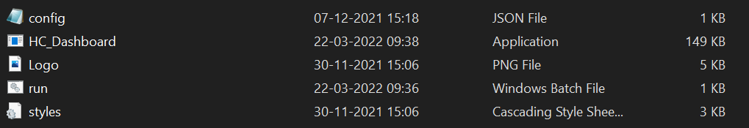

* Create a Rule in the outlook with **“BUR Automation <do.not.reply@dxc.com>”** and create a folder **“Inbox\BURAUTO\HC”** so as to redirect all BUR Health Check mails to that folder.
* Provide the required fields in the **“config.json”.**
* Run the **“Run.bat”** file.
* A HTML file will be opened in Default Browser or it will be available in Dashboard folder as **“Index.html”.**

**Config.json Parameters:**

* **Mailbox :** Provide your mail address.
* **MailLocation:** Provide the path of outlook folder.

**Eg: Inbox\\BURAUTO\\HC**

* **senderMailAddress :** Provide the sender email id.

**Eg:** “BUR Automation <do.not.reply@dxc.com> “ (default)

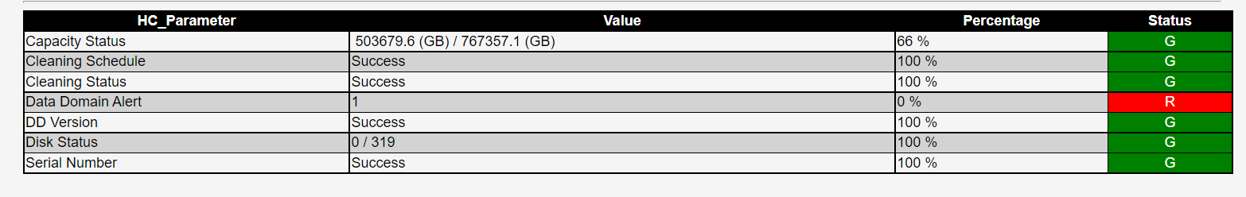

## Credential Script

* If Health-Check is deployed for multiple servers which have different password for each, use Create-Credential solution to create credential file (cred.xml).
* Please find the zip file in share point as **“Create-Credential.zip”.**

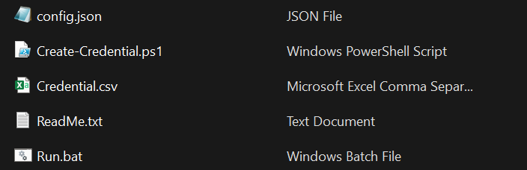

* Provide the usernames, password and paths for the respective servers in credential.csv.
* Run the run.bat file which generates the credential file(Encrypted) in the respective server folders.
* Passwords will be removed from csv after running the script.

## Licence

* The user requires key to run the HealthCheck and Dashboard solutions.
* User need to acquire password from Backup SME or Automation Team.
* Provide the Domain name of the Account where the solutions needs to be run.
* If the HealthCheck solution hosting system and Dashboard solution hosting system are different, request for two licences for both the domains.
* The key provided to you will be like **“Key_DomainName”.** Please rename it to just **“Key”** and place it along with the other files of the solution.
* The key provided to user will be valid till **June** or **December** of that year.
* User needs to request for new key in the month of June or Ddecember for renewing it for the next 6 months.

**Creating Rule in Outlook:**

**A:** Click on File

**B:** Select manage Rules and Alerts

**C:** Click on New Rule

**D:** Under Start From Blank Rule, Select Apply Rule on messages I receive and click Next.

**E:** Select the below mentioned two rows in 1st step of that window.

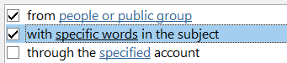

**F:** Open the below mentioned two rows in 2nd step of that window and provide

**“BUR Automation <do.not.reply@dxc.com>”** in people or public group From field and

**“Health Check”** specific words part and click ok.

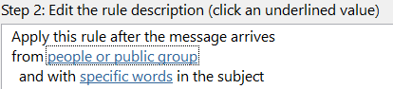 

**G:** Select the below mentioned row in 1st step of that window.



**H:** Open the move to **Specified** row in 2nd step of that window and create a new folder as

“**BURAuto_HC**” and click finish.

